Mitchell Barker

HW 2: Authentication Lab

1. *Obtain the password file*After downloading the db.txt file will all the user data, I created a C++ program structure with two classes: User and Database. The User class took in each line and assigned values to its members. The Database contains all the Users.
2. *Implement a password authenticator*A password authenticator was made as a member of the User class. Using a function User.authenticate(), the main.cpp file did a simple check of the database. This was tested with an example username: “mbarker2” and password: “purplegiraffe” after they were added to the database.  
   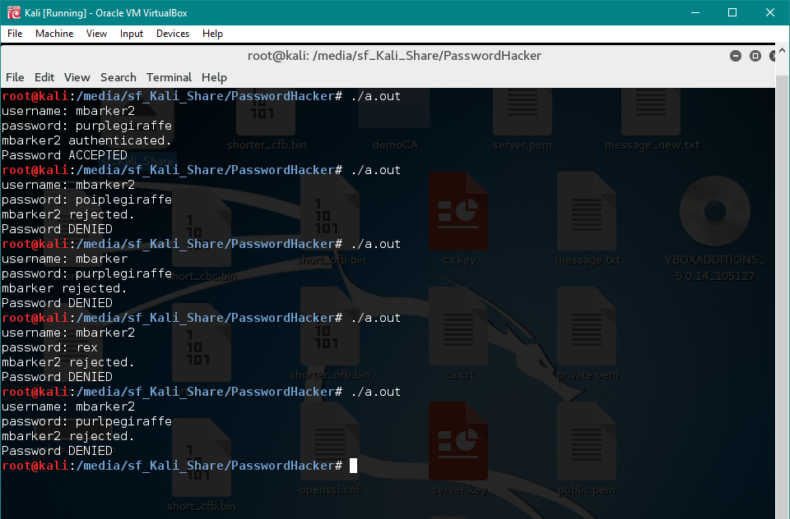
3. *Compare hash algorithms*The following screenshots show me using the opeenssl speed tools to gauge md5, sha1, sha256, and sha512. They test each one for blocks of sizes 16, 64, 256, and 512. Based on the results and the 1000s of bytes per second processed, md5 and sha1 are the quickest hashes. Sha1 is a bit quicker. Sha256 and sha512 are much slower. I imagine md5 was chosen because it is one of the quicker hashes. We can compute the data much faster and actually come up with results. Sha512 would have taken much longer.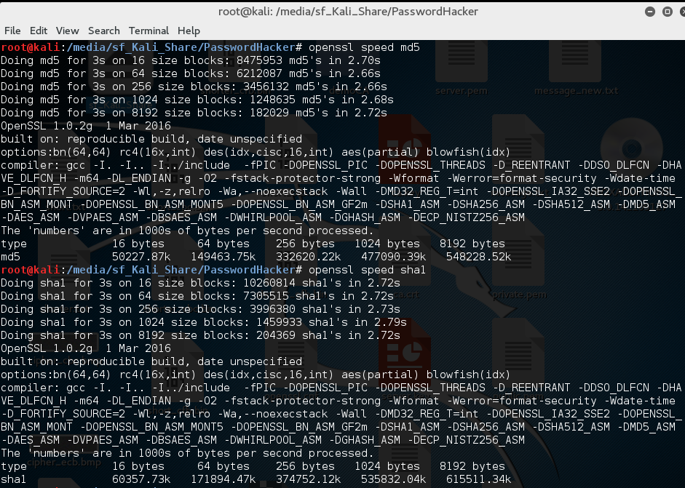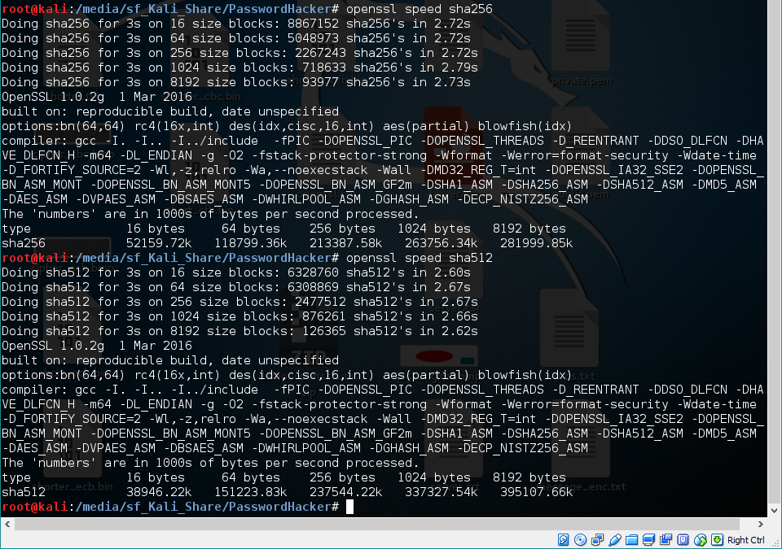
4. *Write a brute force password cracker*I created a brute force function to my database class. It goes through all possible values from “” to “a” to “b” and so on, determining if its hash authenticates the user/password pair. Because the problem increases exponentially, it solves all the very short passwords quickly and then takes forever to solve passwords of any length (generally, greater than 4). The following snapshot shows the program after seconds of runtime:  
   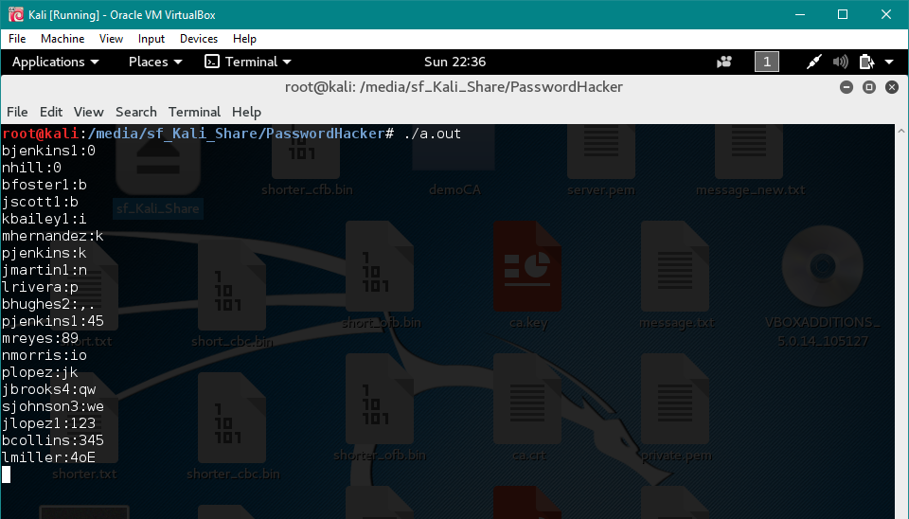  
     
   One minute later:  
   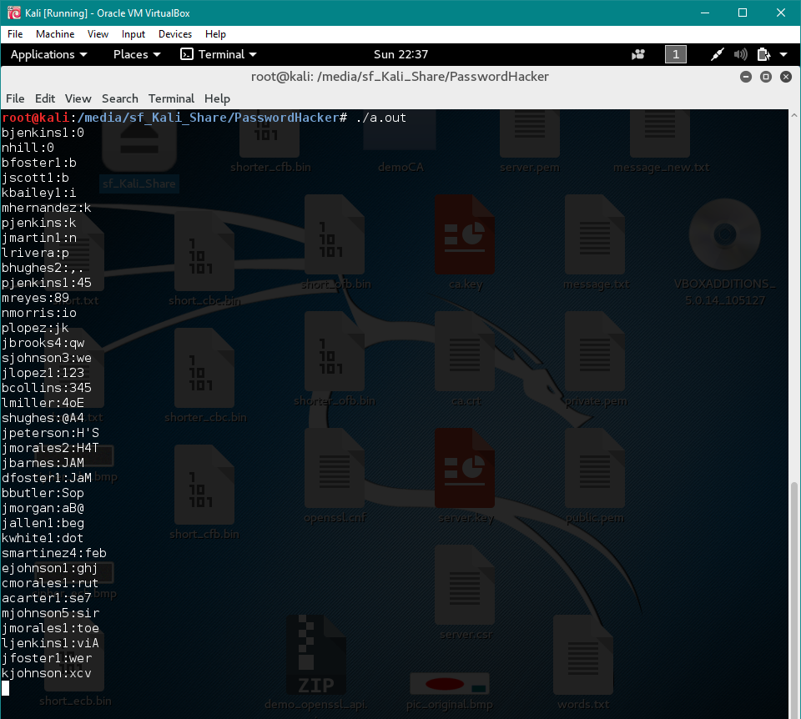  
     
   After this speed, it takes about an hour to come to this:  
   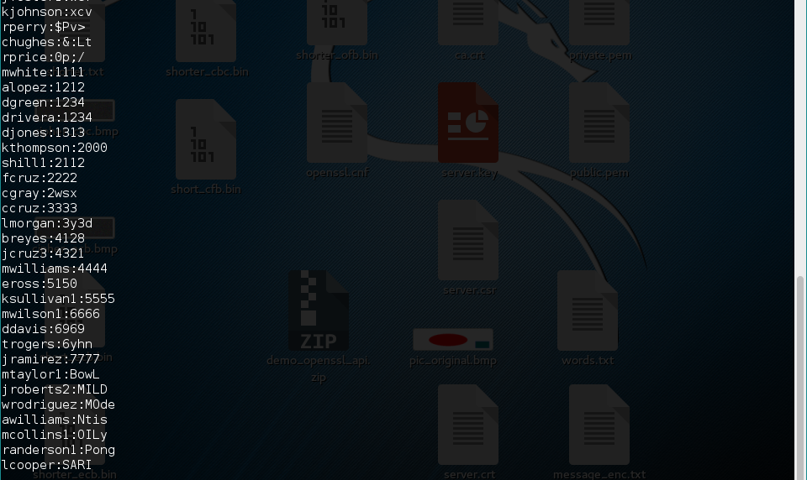  
   You can see the top user:password corresponds to the bottom in the previous picture, but the rest are new. By the time the brute force method goes through just four-character length strings, it has tried about 100,000,000 password values. Obviously, this makes the program’s time increase exponentially.  
     
     
   This approach could be improved in several ways. The current approach checks all valid ASCII inputs (from ! to ~). To increase passwords solved, by sacrificing thoroughness, you could limit the space to alphanumeric characters. It also checks EVERY combination. You could decrease time by checking only “memorable” combinations. Most users will only select somewhat pronounceable passwords and this can be checked for.
5. *Implement a dictionary attack*I have no idea why my dictionary attack seems to differ from the majority, but my dictionary attack literally took 60 seconds. I increased my dictionary size to a ridiculous amount by combining the Cain and Abel dictionary and the John the Ripper dictionary. It contains over 300,000 words.   
     
   Implementing the dictionary attack (in less than 60 seconds), I found 591 passwords.  
   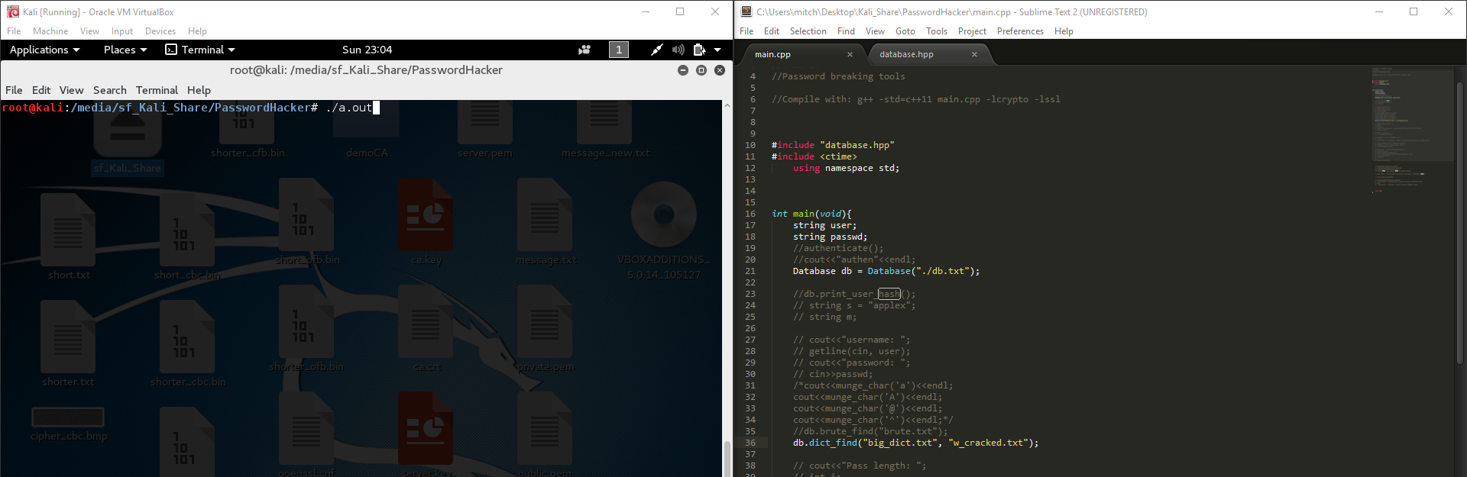  
   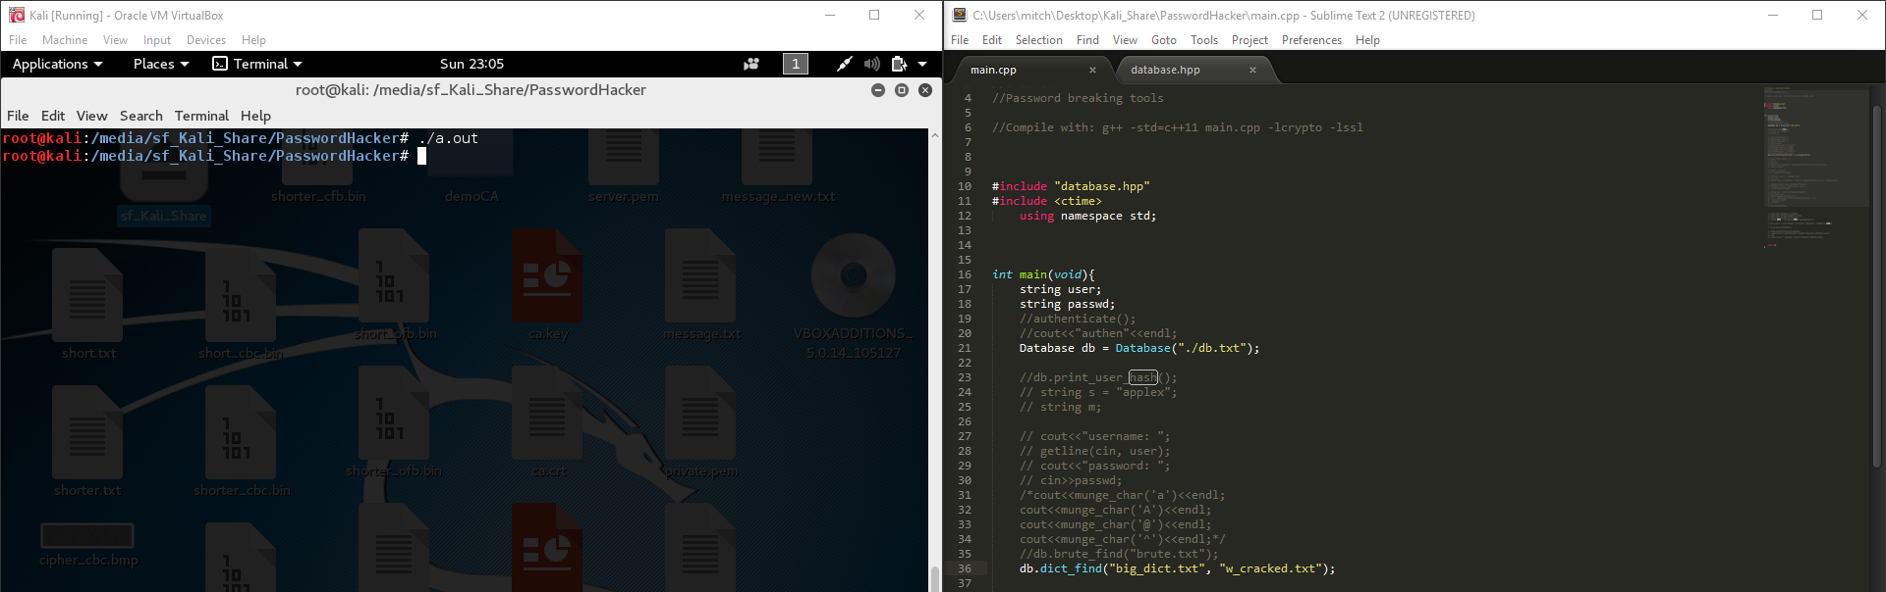  
   You can see only a minute has passed.  
   This is the tail end of the generated cracked passwords:  
   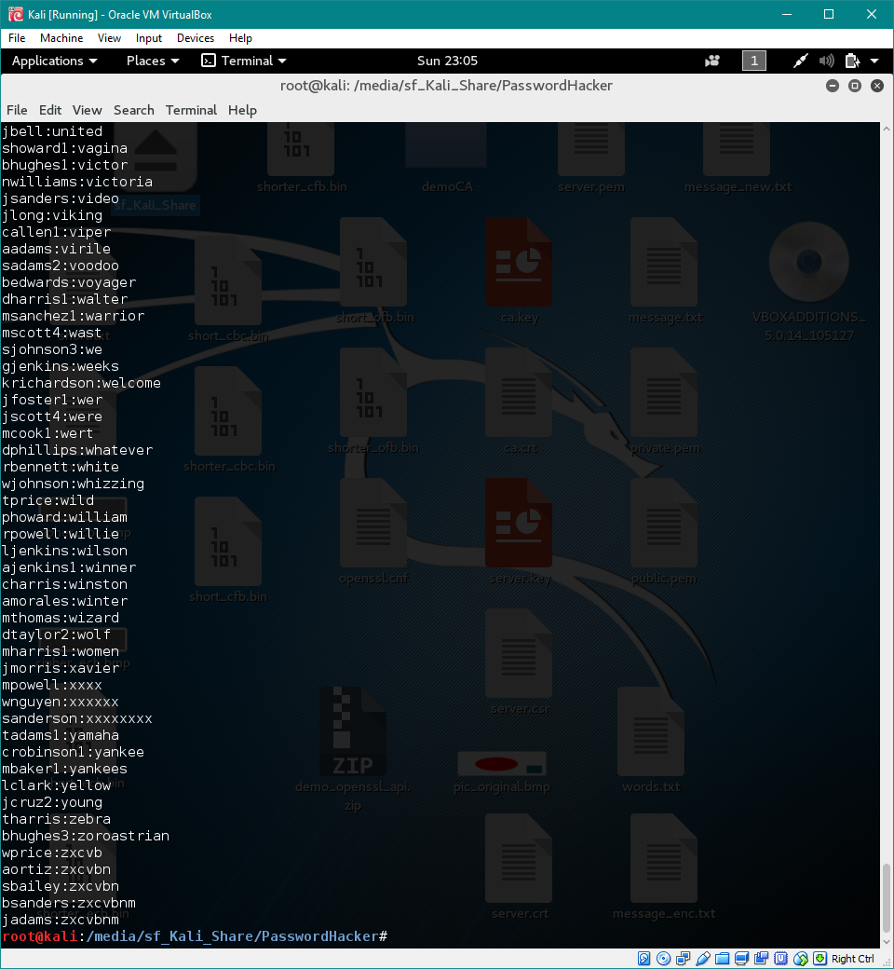  
   The dictionary was sorted alphabetically using the linux command “sort”. I tried to build the dictionary as comprehensively as possible, but I think the dictionary attack is just too fast to merit waiting an hour.
6. *Implement a password generator and strength meter*I made a program which asks the user the length of the desired password and then generates a password for them. The program works by the main.cpp calling the gen_password() function which takes a dictionary and password length as arguments. The dictionary should be determined by someone other than the user. The function works by randomly appending words from the dictionary so that they meet the required password length. The default is to substitute a common special character or number and to substitute a capitalized character. The function’s parameters allow this to be determined. Here is an example with the default parameters:  
   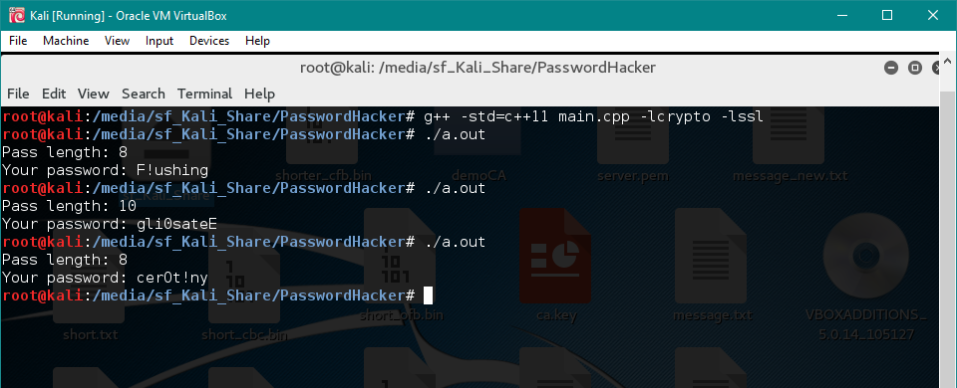  
     
   Here is the same program with parameters 2 and 2 for adding special/numbers and capital letters:  
   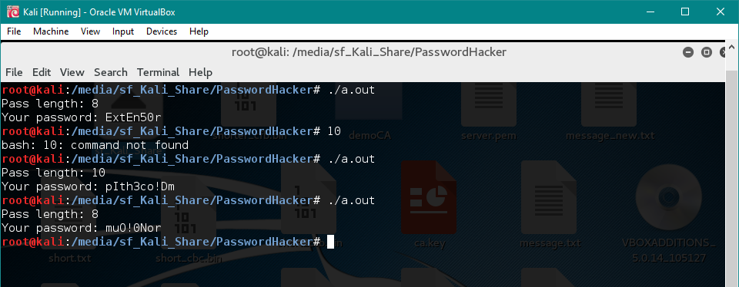  
     
   I did not allow myself time to create a password strength meter.
7. *Extend the dictionary attack with password generation/modification rules*Besides, a 38th password which I lost due to a Windows Update, here are the 37 passwords found by an expanded dictionary attack:  
   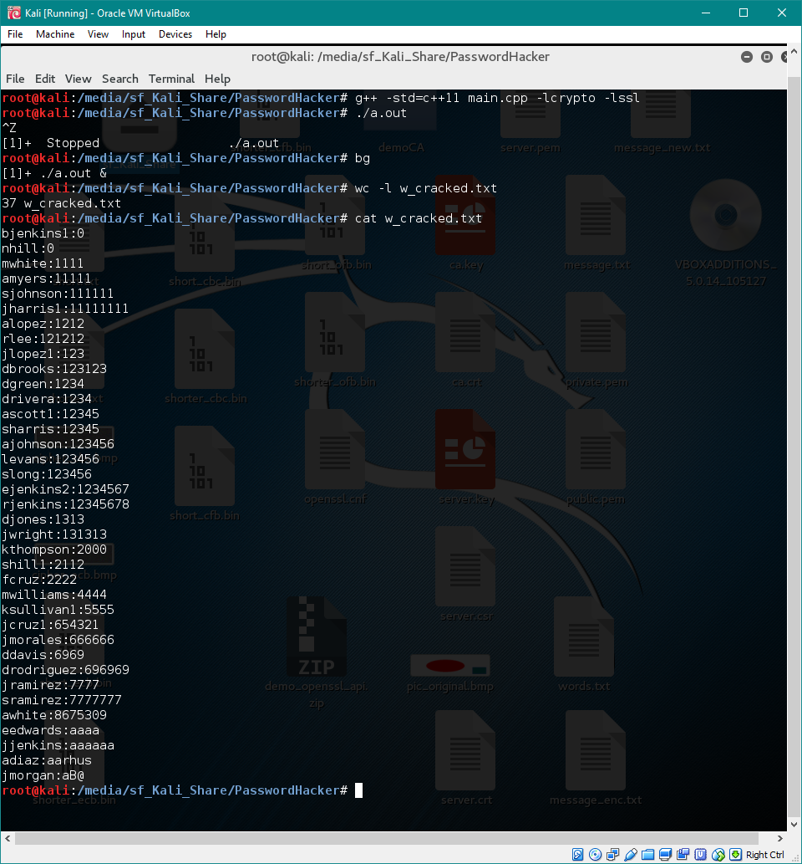  
   Unfortunately, I let my program run for over 8 hours, and only one more password was found. These 37 were found within a minute. My expanded dictionary checked each possible permutation over the 300,000 words in my big_dict.txt file (the combination of cain and jack the ripper). It checked most common special character and number replacements along with every possible capitalization.   
     
   I think the main disadvantage, of not having all permutations in a file, is time. The main advantage is usability. You can easily add in another password that your function can permute for all values.
8. *Use John the Ripper*Using the commands given, I tried John the Ripper. Here is the tail of its output:  
   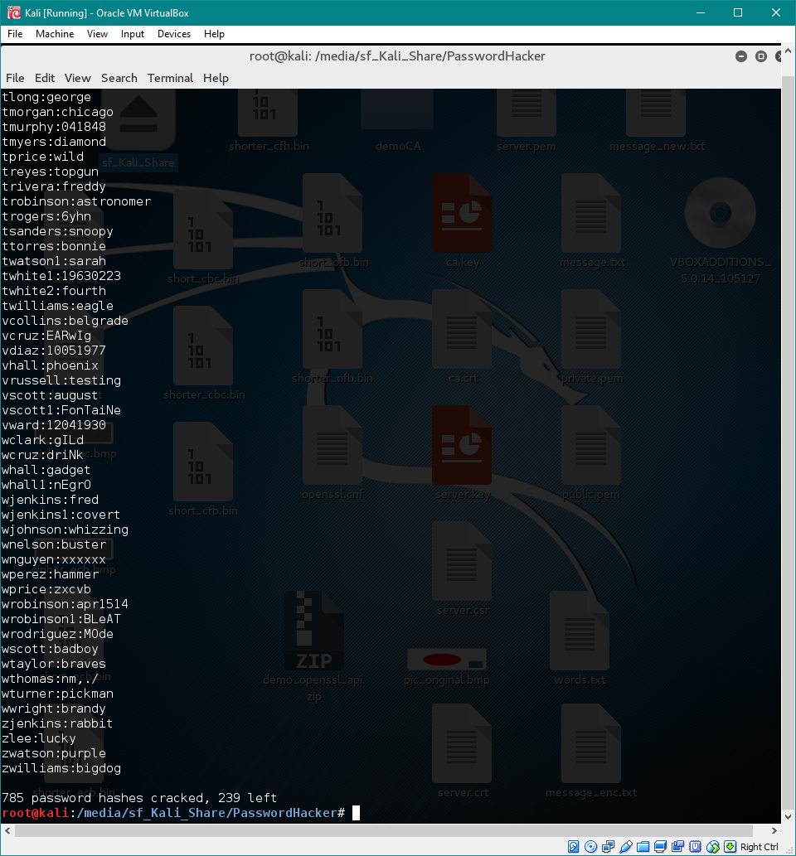  
   It solved 785 passwords in a very short amount of time. Combined with my other password-cracking attempts, I only solved 18 unique passwords that John the Ripper did not.
9. *Submit the assignment*